
CONSENT COMPLIANCE ASSESSMENT
BETA TEST RELEASE
https://www.wisetack.com
Test date: 2026-04-01
CMP: Enzuzo CMP
2 FAIL · 4 PASS · 5 MANUAL

1. Executive Summary
Automated consent compliance testing identified 2 violations on https://www.wisetack.com. Manual review of remaining items is recommended.

2. Consent State Screenshots
Captured automatically. Assessed by AI for K.1/K.2/K.3 UX compliance.

Default Starting State
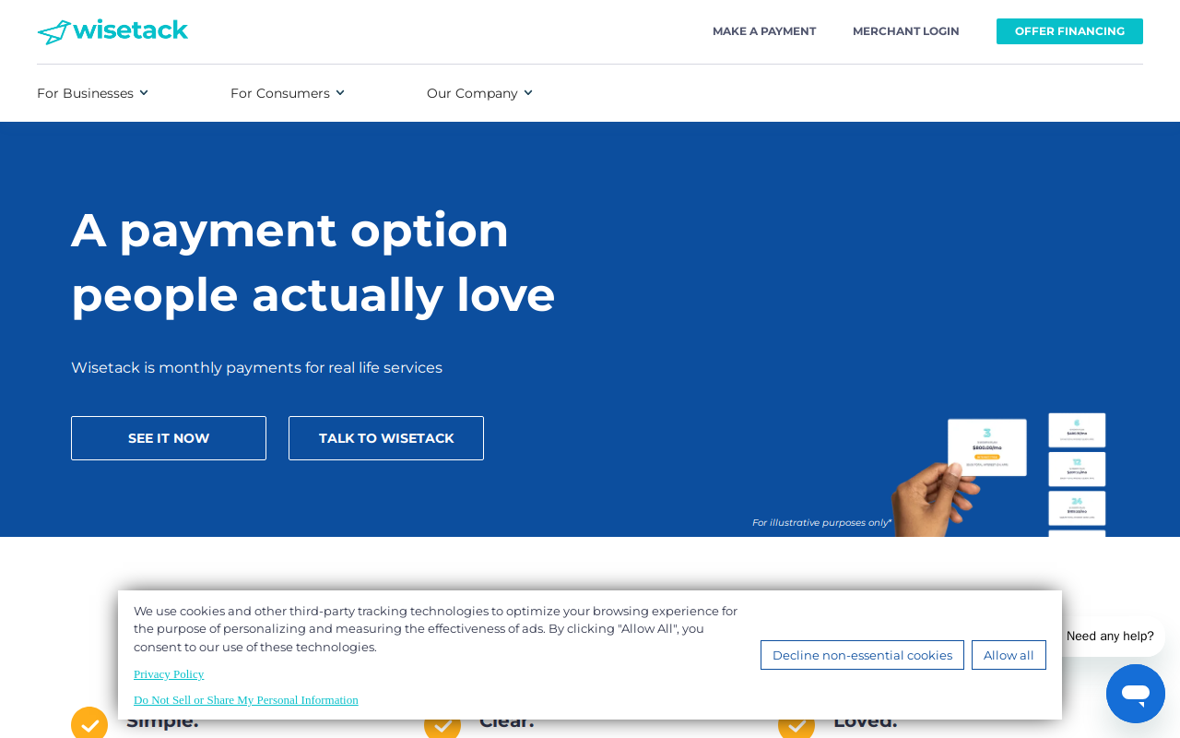
Post Accept Baseline
Post Optout State
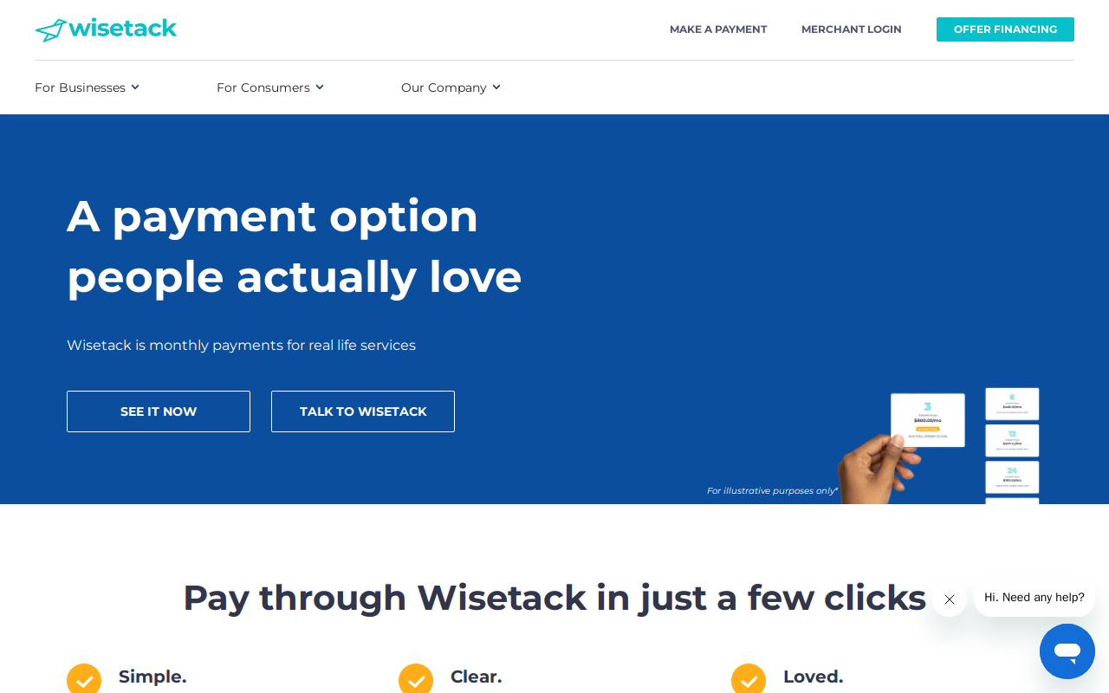

3. Methodology
Conducted using Waivern Consent Analyser (C1: HAR network analysis; C2: Playwright browser automation; C3: AI compliance analysis). Three phases: Accept All, Reject All, persistence check. Framework: ePrivacy Art. 5(3), GDPR Arts. 6/7/25, Datatilsynet guidance.

Parameter | Value
Target URL | https://www.wisetack.com
Test Date | 2026-04-01
Analysis Framework
Probe Location | 🇺🇸 Santa Clara, California, United States (52.52.202.228) — Amazon.com, Inc.
Opt-Out Mechanism | CMP banner (“Decline non-essential cookies”)
Session E: Opt-Out Clicked | Yes — confirmed functional
GPC: US Privacy String | Not implemented
GPC: GPP String | Not detected
Default Tracking Cookies | 13
Default Tracker Globals | GoogleAnalyticsObject, _hjSettings, _hsq, dataLayer, ga, google_tag_manager, gtag, hj, lintrk

⚠️ Important: Results reflect how https://www.wisetack.com presents to the probe location (Santa Clara, California, United States (52.52.202.228) — Amazon.com, Inc.). Sites may show different consent controls to users in different jurisdictions (e.g. GDPR banners only to EU IPs; CCPA opt-out links only to California IPs). Re-run from a different location to test geo-specific behaviour.

4. Summary of Findings
Category | Result
Dnsspi Link Present | PASS
Dnsspi Link Prominent | PASS
Lspi Link Present | MANUAL
Gpc Signal Detected | FAIL
Ad Cookies Suppressed Gpc | MANUAL
Ad Pixels Suppressed Gpc | FAIL
Us Privacy Framework | INFO
Usp Reflects Gpc Optout | MANUAL
Usp Reflects Manual Optout | MANUAL
Optout Destination Functional | PASS
Optout No Login Required | PASS
Optout Preference Recorded | MANUAL

5. Detailed Findings

5.1 High Risk
GPC.1 Site signals GPC opt-out receipt via US Privacy string or GPP
US Privacy string: (none). GPP: (none).
Remediation: Configure the CMP to read the Sec-GPC: 1 request header and the navigator.globalPrivacyControl JS property (set to true) and treat them as an automatic opt-out of sale and sharing. CPRA §1798.135(b) prohibits requiring additional consumer action when a valid opt-out signal is present. CMP platforms (OneTrust, Sourcepoint, Didomi) have built-in GPC support that must be explicitly enabled.

GPC.3 Advertising pixel scripts (Meta, TikTok, LinkedIn etc.) suppressed after GPC opt-out
Default baseline pixels: ['_hsq', 'lintrk']. After GPC opt-out: ['_hsq', 'lintrk']. Pixels still active after GPC opt-out: ['_hsq', 'lintrk']. These constitute 'sharing' for cross-context behavioural advertising under CPRA §1798.140(ah).
Remediation: Advertising pixel scripts (Meta Pixel, TikTok Pixel, LinkedIn Insight Tag, etc.) must not execute when GPC is active. Configure your tag manager or CMP to suppress these tags when navigator.globalPrivacyControl is true.

6. Cookie Inventory
No cookie inventory available.

7. Third-Party Tracker Inventory
No post-reject tracker data available.

8. Remediation Roadmap
Requires ANTHROPIC_API_KEY for AI analysis.

9. Regulatory References
ePrivacy Directive 2002/58/EC Art. 5(3) — terminal device consent requirement.
Norwegian ekomloven para 2-7b — national implementation of ePrivacy Directive.
GDPR (EU) 2016/679 Arts. 5, 6, 7, 25 — lawfulness, consent, withdrawal, privacy by design.
CJEU Planet49 C-673/17 (2019) — pre-ticked boxes invalid; consent must precede processing.
EDPB Guidelines 05/2020 on consent — freely given, as easy to withdraw as give.
EDPB Cookie Banner Taskforce Report (Jan 2023) — reject prominence, dark patterns.
CNIL decisions (Dec 2021) — reject requiring more clicks = GDPR breach.
Datatilsynet, Grindr decision (2022-2023) — RTB without valid consent, NOK 65M fine.
IAB TCF 2.2 Policy (2023) — bid request initiation is itself a processing activity.

Disclaimer
This report is produced by the Waivern Consent Analyser, a product of Waivern Limited. It is provided for informational purposes only and does not constitute legal advice, regulatory guidance, or professional compliance consulting.

No warranty of accuracy or completeness: While Waivern endeavours to maintain accuracy, no representations or warranties, express or implied, are made regarding the accuracy, completeness, reliability, or suitability of any information in this report. Automated analysis may produce false positives or false negatives.

Limitations: This tool analyses websites from a single geographic location at a specific point in time. Results may vary based on network conditions, website configuration changes, A/B testing, bot detection, and other factors.

AI-generated content: AI-enhanced sections of this report are generated using third-party artificial intelligence services. AI outputs including regulatory citations, risk assessments, and remediation recommendations may contain inaccuracies or outdated information and should be independently verified.

Limitation of liability: To the fullest extent permitted by law, Waivern Limited shall not be liable for any direct, indirect, incidental, special, consequential, or punitive damages arising from use of this report.

You should consult qualified legal counsel familiar with your specific circumstances before taking any action based on the findings in this report.

Generated by Waivern Consent Analyser.
© Waivern Limited. All rights reserved.

